**Akshat Parakh**

**MIS 381N User Generated Content Analysis**

**Fall 2017**

**09/21/2017**

**Assignment 1(Edmunds)**

**1.Which forum you chose? (provide URL)**

Ans. I have used the Edmunds forum which is an American online resource of automotive information. The URL is as follows:

<http://forums.edmunds.com/discussion/2864/general/x/entry-level-luxury-performance-sedans/p> .

**2.Which 10 brands you chose and why?**

Ans. The following table depicts the brands I have selected:

|  |  |
| --- | --- |
| BRAND | FREQUENCY |
| BMW | 1796 |
| Audi | 506 |
| Lexus | 505 |
| Honda | 378 |
| Nissan | 316 |
| Subaru | 229 |
| Toyota | 255 |
| Volkswagen | 201 |
| Ford | 160 |
| Porsche | 111 |

**3.Show all lift ratio calculations in a table?**

Ans. Lift ratio for brands:

|  |  |
| --- | --- |
| Brand Pairs | Lift Values |
| bmw_audi | 1.607920984 |
| bmw_lexus | 2.089197116 |
| bmw_honda | 1.181196309 |
| bmw_nissan | 1.182691494 |
| bmw_subaru | 1.198733722 |
| bmw_toyota | 1.335909865 |
| bmw_volkswagen | 1.431539408 |
| bmw_ford | 1.302268931 |
| bmw_porsche | 1.757960633 |
| audi_lexus | 2.185105467 |
| audi_honda | 1.273291925 |
| audi_nissan | 1.300220143 |
| audi_subaru | 1.794190241 |
| audi_toyota | 1.104859335 |
| audi_volkswagen | 4.497079818 |
| audi_ford | 1.83423913 |
| audi_porsche | 2.432432432 |
| lexus_honda | 1.306930693 |
| lexus_nissan | 1.228349417 |
| lexus_subaru | 1.284102209 |
| lexus_toyota | 2.767617938 |
| lexus_volkswagen | 1.580020689 |
| lexus_ford | 1.396782178 |
| lexus_porsche | 2.225314423 |
| honda_nissan | 4.773960217 |
| honda_subaru | 1.50966937 |
| honda_toyota | 5.546218487 |
| honda_volkswagen | 2.423596304 |
| honda_ford | 2.553571429 |
| honda_porsche | 2.265122265 |
| nissan_subaru | 1.477530264 |
| nissan_toyota | 4.865227103 |
| nissan_volkswagen | 2.992631778 |
| nissan_ford | 1.527294304 |
| nissan_porsche | 0.846732809 |
| subaru_toyota | 1.83097868 |
| subaru_volkswagen | 2.193834322 |
| subaru_ford | 2.593886463 |
| subaru_porsche | 1.869467721 |
| toyota_volkswagen | 2.433713784 |
| toyota_ford | 3.202941176 |
| toyota_porsche | 1.888712242 |
| volkswagen_ford | 2.401119403 |
| volkswagen_porsche | 1.863654699 |
| ford_porsche | 2.675675676 |

Lift ratio of brands with attributes:

|  |  |
| --- | --- |
| Association Pairs | Lift Values |
| audi_economical | 2.905063291 |
| audi_luxury | 2.561264822 |
| audi_performance | 2.352475248 |
| audi_reliable | 2.151517462 |
| audi_safe | 2.048503727 |
| bmw_economical | 2 |
| bmw_luxury | 1.903737195 |
| bmw_performance | 1.893287435 |
| bmw_reliable | 1.883360086 |
| bmw_safe | 1.816174672 |
| honda_economical | 1.764262377 |
| honda_luxury | 1.725846408 |
| honda_performance | 1.590514748 |
| honda_reliable | 1.587365214 |
| honda_safe | 1.560820713 |
| lexus_economical | 1.54885507 |
| lexus_luxury | 1.52118241 |
| lexus_performance | 1.485070718 |
| lexus_reliable | 1.481835478 |
| lexus_safe | 1.412126824 |
| nissan_economical | 1.369855993 |
| nissan_luxury | 1.299067066 |
| nissan_performance | 1.232739421 |
| nissan_reliable | 1.055961038 |
| nissan_safe | 0.850292258 |

**4.Show the MDS map (put screenshots in your report).**

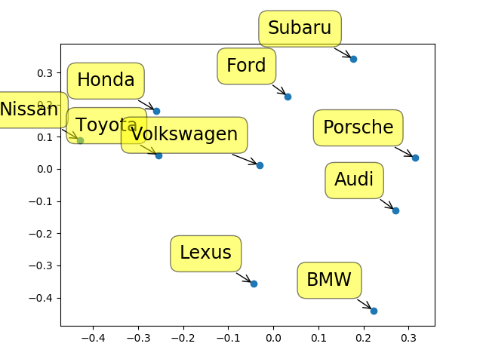

**5.State the attributes and the basis of their selection (again, a summary table with frequencies is good here).**

|  |  |
| --- | --- |
| ATTRIBUTE | FREQUENCY |
| Performance | 741 |
| Luxury | 534 |
| Reliable | 173 |
| Safe | 166 |
| Economical | 110 |

**TASK A**

After calculating the lift values for 10 brands that have the highest frequencies, I plotted a MDS map using mds_map.py.

From the map, we can arrive at a few conclusions for the brands involved. The advice I would give to brand managers are following:

* There is high association between Lexus and luxury cars like BMW, Audi. This implies that when people are talking about luxury cars, they are including Lexus in that comment. Managers at Lexus can use this information and promote Lexus as luxury car.
* Toyota has high association with Honda. This can be interpreted as Toyota and Honda being competitors and there are high chances of people shifting from Toyota to Honda or vice versa.
* Nissan, Toyota, Honda, Volkswagen, Ford and Subaru can be grouped together as economical cars.
* Volkswagen can be seen at boundary of economical group, so switching behavior can be observed.
* Using data from task B, Lexus should be promoted as a luxury brand. Lexus’s image should be improved by keeping safety as a factor.
* BMW needs to work hard in promoting their cars as luxurious. Audi should do the same thing.

**TASK B**

The brands having highest association with attributes are:

* Performance - Honda (1.5905)
* Luxury - Lexus (2.0485)
* Reliability – Lexus (1.9037)
* Safe – Nissan (2.1515)
* Economical – Nissan (2.90506)

Advice to Product Managers:

* BMW- Product managers can work on enhancing of the luxurious features. Introducing an economical version will be beneficial as people who cannot afford the high-end versions can still enjoy the brand.
* Audi- Performance association of Audi is lowest. Enhancing performance can increase sales. Luxurious features of the brand should be promoted and advertised in a more efficient manner. Safety features of the vehicles can be improved upon.
* Lexus- Association with safety is lowest, hence safety features can be improved.
* Honda- Reliability of Honda manufactured cars should be improved to promote a better brand image.
* Nissan- Performance of Nissan cars should be improved. Nissan has the lowest association with reliability, so that is an area for improvement.

**TASK C**

**Which is the most aspirational brand among the top 5? How did you find the answer? Show all steps.**

Ans. Lexus is the most aspirational brand.

|  |  |  |  |  |  |
| --- | --- | --- | --- | --- | --- |
|  | Performance | Luxury | Reliability | Safe | Economical |
| BMW | 1.481835 | 1.41212 | 1.81617 | 1.485 | 1.2327 |
| Audi | 1.29906 | 1.5608 | 1.7642 | 1.055 | 2.56126 |
| Lexus | 1.5873 | 2.0485 | 1.90373 | 0.8502 | 2.3524 |
| Honda | 1.5905 | 1.8833 | 1.7258 | 1.8932 | 2 |
| Nissan | 1.3698 | 1.5488 | 1.5211 | 2.1515 | 2.90506 |

Using the lift association values that were calculated for task B, I was able to construct the table above.

* Lexus has the highest association with luxury and reliability. Nissan has the highest association with safe and economical.
* Lexus has more frequency than Nissan, higher association with performance which is the attribute with highest frequency.
* The above 2 points makes Lexus more aspirational than Nissan.
* Even though BMW and Audi have more frequency than Lexus, their association with most attributes is less than that of Lexus.
* Honda has the highest association with performance, among all the brands. Lexus has highest association with Luxury and Reliability. Lexus is more economical but less safe than Honda. Honda has higher association with performance than Lexus by less than 0.01. Since Lexus has 32.2% more mentions than Honda, the difference in association with performance can be overlooked.
* Thus, proving that Lexus is the most aspirational brand.